DAFTAR PERALATAN & HARDWARE REKOMENDASI INTERMODAL DRY PORT
No. | Hardware | Contoh / Model | Spesifikasi Utama | Harga / Unit | Link
1 | 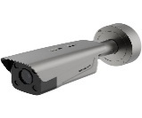  Kamera ANPR Gate | Hikvision DS-TCG406-E / Seri ANPR | Pembacaan plat nomor otomatis, capture kendaraan, outdoor IP67, integrasi barrier gate & YMS | Rp16 jt | https://www.hikvision.com/id/products/parking-management/vehicle-access-control-management/anpr-cameras/ds-tcg406-e/
2 | 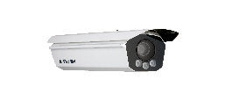  Kamera OCR Kontainer | Hikvision iDS-TCV300-A6I / Container OCR Portal | Membaca nomor kontainer ISO 6346 (4 huruf + 7 angka), multi-angle recognition, integrasi gate system | Rp55 jt | https://www.hikvision.com/id/products/ITS-Products/Checkpoint-Systems/Checkpoint-Capture-Units/ids-tcv300-a6i/
3 | 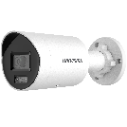  CCTV Yard 4 MP | Hikvision DS-2CD2046G2H-IU | 4 MP, IP67 weatherproof, IR night vision, PoE, monitoring area penumpukan umum | Rp3,5 jt | https://www.hikvision.com/en/products/IP-Products/Network-Cameras/Pro-Series-EasyIP-/ds-2cd2046g2h-i-u-/
4 | 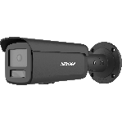  CCTV Yard 8 MP | Hikvision DS-2CD2T87G2H-LI | 8 MP / 4K UHD, ColorVu night vision, outdoor IP67, perimeter boundary monitoring | Rp6,5 jt | https://www.hikvision.com/id/products/IP-Products/Network-Cameras/Pro-Series-EasyIP-/ds-2cd2t87g2h-li/?subName=DS-2CD2T87G2H-LI
5 | 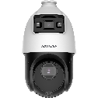  CCTV PTZ | Hikvision DS-2SE4C425MWG-E/14 TandemVu | Pan-tilt-zoom 25x optical zoom, dual-channel panoramic + PTZ, pemantauan area luas 360° | Rp10,3 jt | https://www.hikvision.com/id/products/IP-Products/PTZ-Cameras/Pro-Series/ds-2se4c425mwg-e-14-f0-/
6 | 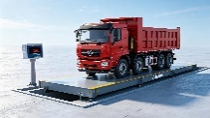  Weighbridge / VGM Scale | Fangda Electronic Truck Scale 80 Ton | Jembatan timbang kendaraan kapasitas 80 ton, digital load cell indicator, sertifikasi SOLAS VGM, integrasi YMS | Rp267 jt | https://cnfjkeda.en.made-in-china.com/product/aQRUXTBbvLYe/China-60-Ton-80-Ton-Weighbridge-Price-Electronic-Truck-Scale.html
7 | 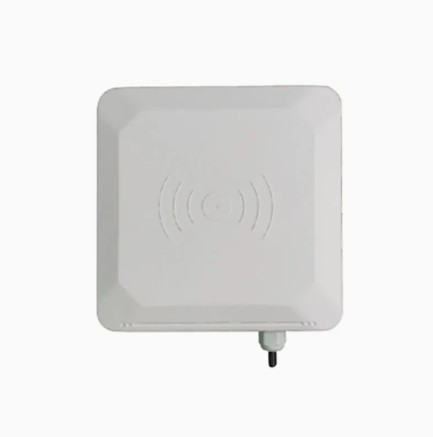  RFID Reader | Long-Range UHF RFID Reader (20m) | Frekuensi 860-960 MHz, jarak baca hingga 20 meter, identifikasi e-Pass & armada truk otomatis | Rp3 jt | https://www.orbitadigital.com/en/access-controls/accessories/19689-uhf-reader-20m-access-reader-uhf-tag-access-range-up-to-20-m.html
8 | 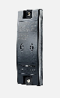  RFID Tag | RFID UHF ID Tag ISO (TRANSIT & ATEX) | Tag pasif UHF anti-metal standar ISO 18000-6C, identitas truk mitra / kartu akses pengemudi | Rp690 ribu/pack | https://www.ebay.com/itm/316860017458
9 | 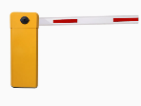  Barrier Gate | High-Speed Automatic Barrier Gate | Palang otomatis 3 meter, motor DC brushless (kecepatan buka 1-1.5 detik), sensor loop detector, integrasi ANPR/RFID | Rp60 jt | https://jutaigateopener.en.made-in-china.com/product/MObfpFLKLorl/China-Automatic-Barrier-Gate-with-Single-Bar-Gate-Arm-Barrier-Automatic-Parking-Gate-Barrier.html
10 | 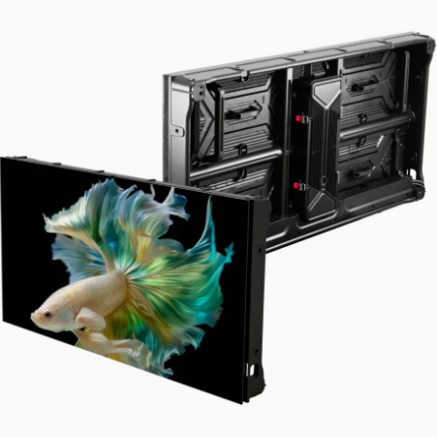  LED Information Display | Outdoor P6/P8 Industrial LED Display | Menampilkan nomor gate, instruksi sopir ("SILAHKAN MASUK"), nomor kontainer, dan blok tujuan yard | Rp47 jt | https://chipshow.en.made-in-china.com/product/KYarZvkHyFhd/China-Sc-Smart-P6-67-Outdoor-LED-Display-for-Wall-Mounted-Advertising.html
11 | 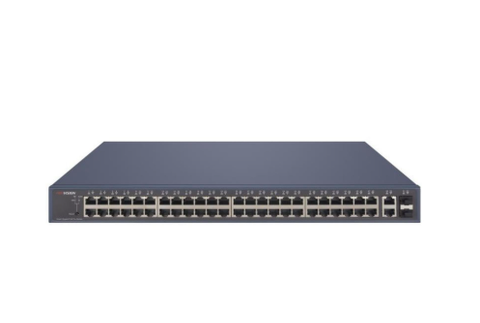  Industrial Network Switch | Managed Industrial PoE+ Gigabit Switch | Switch industri 16/24-Port PoE+ Gigabit, casing logam IP40, tahan suhu ekstrem lapangan, redundant power input | Rp10 jt | https://global.microless.com/product/tp-link-jetstream-48-port-gigabit-l2-managed-switch-with-4-gigabit-sfp-slots-t2600g-52ts-tl-sg3452/
12 | 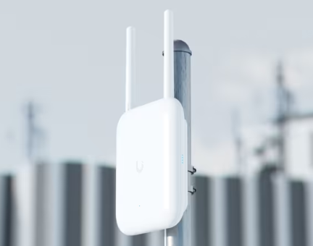  Access Point Outdoor | Ubiquiti U7 Pro Outdoor / UniFi WiFi 7 AP | Tri-Band WiFi 7 outdoor, casing IP67 weatherproof, jangkauan luas untuk konektivitas VMT & PDA di yard | Rp7,2 jt | https://www.aloinfousa.com/products/ubiquiti-networks-unifi-u7-pro-outdoor-tri-band-wi-fi-7-access-point
13 | 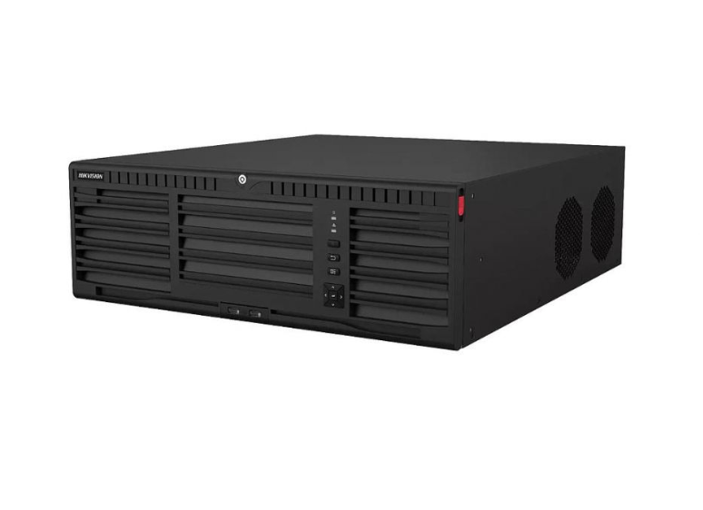  Server / NVR | Hikvision DS-9664NI-M16/R 64-Ch NVR & Server | NVR 64-Channel 4K, 16 SATA bay, redundant PSU, rekaman CCTV yard & gate, integrasi database YMS | Rp102 jt | https://www.orbitadigital.com/en/cctv-ip/ip-nvr-recorders/56602-hikvision-solutions-ds-9664ni-m16-r-hikvision-nvr-recorder-64-ch-ip-solutions-maximum.html
14 | 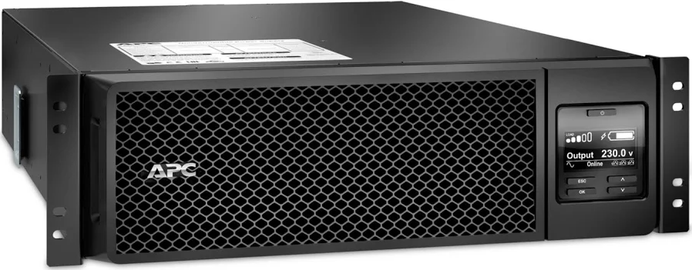  UPS Online | APC Smart-UPS SRT 5000VA RM 230V (SRT5KRMXLI) | UPS On-Line double conversion 5kVA/4.5kW, rackmount 3U, backup daya darurat server & gate automation | Rp81 jt | https://www.monotaro.id/items/s013485894.html
15 | 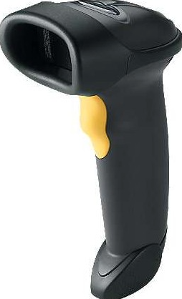  Barcode / QR Scanner | Zebra Symbol LS2208 Handheld Scanner | Laser barcode/QR scanner 1D/2D, USB, scan dokumen surat jalan, gate pass, e-Ticket booking pos sekuriti | Rp1,6 jt | https://www.monotaro.id/items/s003425886.html
16 | 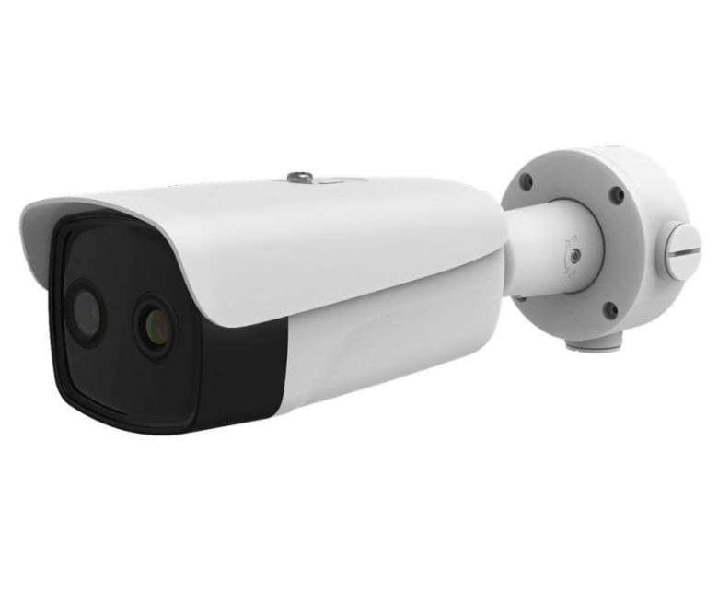  Thermal Camera Reefer | Hikvision DS-2TD2636B-13/P Thermal & Optical | Pemantauan suhu permukaan reefer container, deteksi dini overheat kompresor & alarm kebakaran cold chain | Rp30 jt | https://www.hikvision.com/en/products/Thermal-Products/Thermography-thermal-cameras/temperature-screening-series/ds-2td2636b-13-p/
17 | 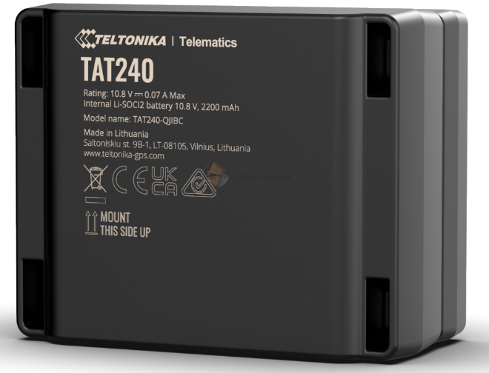  GPS Tracker Truck | Teltonika TAT240 4G LTE Asset Tracker | Pelacak posisi armada truk real-time, 4G Cat M1/NB-IoT, baterai internal otonom, tracking perjalanan Priok - Cikarang | Rp2,5 jt/unit | https://www.slapukas.lt/ee/teltonika-tat240
18 | 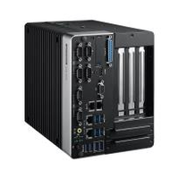  Industrial Edge AI PC Gate | Advantech ARK-3532 / Neousys Nuvo-9000 Fanless | Intel Core i7, Fanless Rugged, suhu operasional -20°C s/d 60°C, catu daya 9-48V DC, IP40, Dual GbE PoE, 4x COM RS-232/422/485 untuk Timbangan & PLC Gate | Rp42 jt | https://www.advantech.com/en/products/fanless-embedded-box-pcs/ark-3532/
19 | 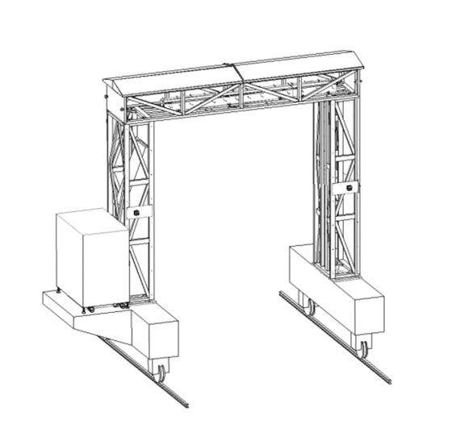  Gantry Container X-Ray | Nuctech MB1215DE / Smiths Detection HCVG | High-Energy X-Ray (6 MeV), penetrasi baja >300 mm, throughput 20-25 truk/jam, pemindaian peti kemas jalur merah & integrasi CEISA 4.0 Bea Cukai | Rp12,5 Miliar | https://www.nuctech.com/en/product/high-energy-container-and-vehicle-inspection-system/
20 | 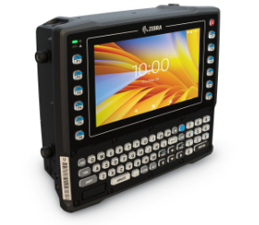  Vehicle Mounted Terminal (VMT) | Zebra VC8300 Rugged Vehicle Mounted Terminal | Android Enterprise, layar sentuh 8 inci ultra-bright, keyboard fisik, tahan getaran MIL-STD-810G & IP66 untuk kabin Reach Stacker / RTG | Rp74 jt | https://www.zebra.com/ap/en/products/mobile-computers/vehicle-mounted/vc8300/vc8300.html
21 | 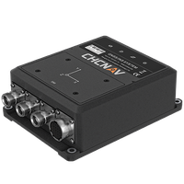  DGPS / RTK GNSS Receiver | CHCNAV CGI-610 / Hemisphere GNSS | Dual-antenna RTK GNSS + IMU sensor, akurasi centimeter (<2 cm), update rate 50Hz, RS-232/CAN Bus, IP67 rugged untuk Reach Stacker & RTG auto Bay-Row-Tier | Rp45 jt | https://chcnav.com/product-detail/cgi-610-gnss-ins-sensor
22 | 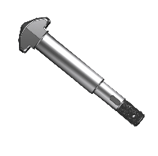  Spreader Twistlock & Load Cell | Bromma / Kalmar SmartSpreader Sensor Kit | Inductive proximity sensors (twistlock engaged/unlocked), 4x load cell telemetry (gross weight), RS-485/CANopen, tahan getaran maritim untuk Reach Stacker | Rp35 jt | https://www.bromma.com/products/sensors-telematics/
23 | 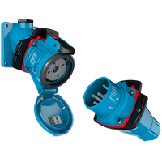  Smart Reefer Power Socket | Marechal / Cavotec 380V/32A Smart Receptacle | 3P+N+E 32A 380V IP67, built-in Modbus RTU / LoRaWAN energy meter & continuous temperature logging, trip detection untuk 300 titik reefer yard | Rp8,5 jt/titik | https://marechal.com/en/products/decontractor/smart-reefer-sockets
24 | 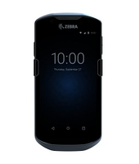  Rugged Mobile PDA | Zebra TC57x / Honeywell CT60 | Android Enterprise, 2D Long-Range Barcode Imager, IP68 tahan banting/air, 4G LTE & WiFi 6, hot-swappable battery untuk tallyman & inspeksi kontainer (EIR) | Rp16 jt | https://www.zebra.com/id/id/products/mobile-computers/handheld/tc57.html
25 | 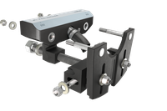  Rail Trackside Axle Counter | Frauscher RSR123 Wheel Sensor | Inductive rail head sensor, deteksi arah gerak KA, hitung as roda (axle count), estimasi kecepatan, IP68, SIL 4 untuk Intermodal Rail Siding KA Logistik | Rp85 jt | https://www.frauscher.com/en/products/wheel-sensors/frauscher-wheel-sensor-rsr123
26 | 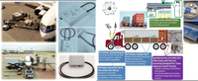  Electronic Cargo Smart Seal | Jointech JT701 GPS Smart E-Seal | GPS/GSM/RFID Smart Electronic Lock, sensor kawat anti-tamper, masa pakai baterai 30 hari, IP67 untuk kontainer transit Bea Cukai Priok - Cikarang (CEISA 4.0) | Rp3,2 jt/unit | https://www.jointech.com/product/jt701-smart-gps-electronic-seal-tracker.html

